Miami Tower, Sky Lounge, Miami Jazz Society and
Community Cultural Discovery Exchange present
2012
Downtown Jazz Series
Miami Tower Film Series
Community Building and Education Series
September Events
6:15 pm - 8:15 pm | Death in Venice - Tuesday, 9/4/12  In this adaptation of the Thomas Mann novel, avant-garde composer Gustave Aschenbach (loosely based on Gustav Mahler) travels to a Venetian seaside resort in search of repose after a period of artistic and personal stress. But he finds no peace there, for he soon develops a troubling attraction to an adolescent boy, Tadzio, on vacation with his family. The boy embodies an ideal of beauty that Aschenbach has long sought and he becomes infatuated. However, the onset of a deadly pestilence threatens them both physically and represents the corruption that compromises and threatens all ideals. (Drama/Fantasy) | 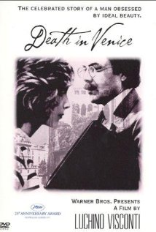
8:30 pm - 10:30 pm | The Miracle Worker - Tuesday, 9/4/12  Young Helen Keller, blind, deaf, and mute since infancy, is in danger of being sent to an institution. Her inability to communicate has left her frustrated and violent. In desperation, her parents seek help from the Perkins Institute, which sends them a "half-blind Yankee schoolgirl" named Annie Sullivan to tutor their daughter. Through persistence and love, and sheer stubbornness, Annie breaks through Helen's walls of silence and darkness and teaches her to communicate. (Biography/Drama) | 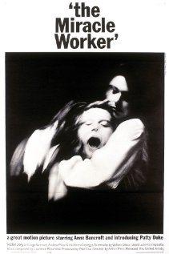
6:15 pm - 8:15 pm | Not For Ourselves Alone: The Story of Elizabeth Cady Stanton and Susan B. Anthony - Tuesday, 9/11/12  Elizabeth Cady Stanton and Susan B. Anthony were two heroic women who vastly bettered the lives of a majority of American citizens. For more than fifty years they led the public battle to secure for women the most basic civil rights and helped establish a movement that would revolutionize American society. Yet despite the importance of their work and they impact they made on our history, a century and a half later, they have been almost forgotten. They were nearly total opposites in their personalities and attributes, yet complemented each other's strengths perfectly. Stanton was a gifted writer and radical thinker, full of fervor and radical ideas but pinned down by her responsibilities as wife and mother, while Anthony, a tireless and single-minded tactician, was eager for action, undaunted by the terrible difficulties she faced. As Stanton put it, "I forged the thunderbolts, she fired them." The relationship between these two extraordinary women and its effect on the development of the suffrage movement are richly depicted by Ward and Burns, and in the accompanying essays by Ellen Carol Dubois, Ann D. Gordon, and Martha Saxton. Not For Ourselves Alone is a vivid and inspiring portrait of two of the most fascinating, and important, characters in American history. (Biography, Social History, Gender Issues) | 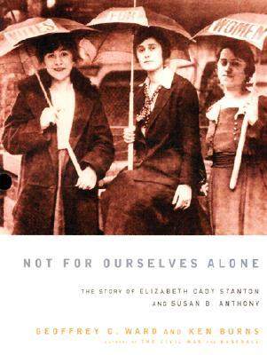
7:00 pm - 10:00 pm | Orienté (Jazz Band) - Wednesday, 9/12/12
6:15 pm - 8:15 pm | Igby Goes Down - Tuesday, 9/18/12  Igby Goes Down is a personal tale about a 17 year old misfit boy who copes with his mother's cancer and his father's insanity by pursuing relationships with older women. Truly an intellectual, Igby is a modern day Holden Caulfield, and the world he lives in is far removed from the high standards of expectation he holds for it. (Comedy/Drama) | 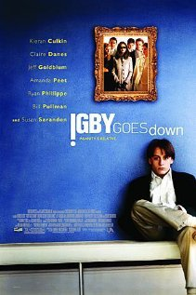
8:30 pm - 10:30 pm | Myra Breckinridge - Tuesday, 9/18/12  Myron Breckinridge is waiting for his sex-change operation while a stoned surgeon stumbles into the operating room. Before the drugged doctor begins Myron's operation, he counsels him. Myron persists and the doctor goes through with it. An enthusiastic audience observing the operation applauds the medical achievement and rises in a standing ovation. After the operation, Myron arrives in Hollywood as Myra while in the rest of the film Myron pops up from time to time as Myra's alter ego. Myra goes to an acting academy owned by her uncle, Buck Loner, a former cowboy star. The real reason for Myra's arrival is to claim her half of Uncle Buck's estate, which she says she's entitled to. Buck Loner stalls by giving her a job teaching the history of motion pictures. Buck Loner has several friends. One of them is Letitia Van Allen, an ancient Hollywood talent scout. The sex-starved septuagenarian runs an acting agency "for leading men only." (Comedy) | 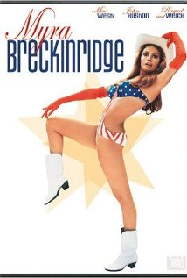
6:15 pm - 8:15 pm | Paul Robeson - Tuesday, 9/25/12  Paul Robeson was the epitome of the 20th-century Renaissance man. He was an exceptional athlete, actor, singer, cultural scholar, author, and political activist. His talents made him a revered man of his time, yet his radical political beliefs all but erased him from popular history. Today, more than one hundred years after his birth, Robeson is just beginning to receive the credit he is due. To this day, Paul Robeson's many accomplishments remain obscured by the propaganda of those who tirelessly dogged him throughout his life. His role in the history of civil rights and as a spokesperson for the oppressed of other nations remains relatively unknown. In 1995, more than seventy-five years after graduating from Rutgers, his athletic achievements were finally recognized with his posthumous entry into the College Football Hall of Fame. Though a handful of movies and recordings are still available, they are a sad testament to one of the greatest Americans of the twentieth century. If we are to remember Paul Robeson for anything, it should be for the courage and the dignity with which he struggled for his own personal voice and for the rights of all people | 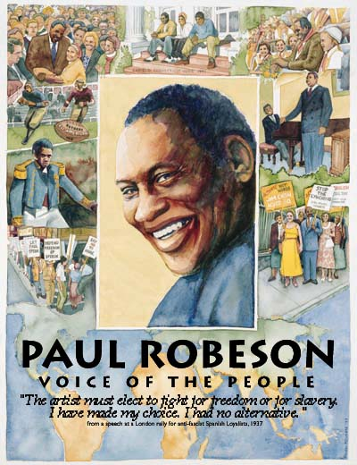
8:30 pm - 10:30 pm | Marian Anderson - 9/25/12  Marian Anderson was 42 when she sang her legendary open-air concert at the Lincoln Memorial on 9 April 1939. Anderson was a famous contralto of the day, and the concert was arranged after the Daughters of the American Revolution refused to let her perform at Constitution Hall because she was black. (First Lady Eleanor Roosevelt resigned from the DAR in protest and helped arrange the concert at the Lincoln Memorial.) The concert is legendary in the American civil rights movement and, despite Anderson's many other musical successes, became the signature moment in her long international career. Anderson broke many other color barriers, including becoming the first African-American to sing at the White House and at New York's Metropolitan Opera. Anderson was the aunt of former Oregon Symphony conductor James DePriest... Anderson was honored on a stamp from the U.S. Postal Service in 2005... Martin Luther King, Jr. gave his famous "I Have a Dream" speech at the Lincoln Memorial in 1963. | 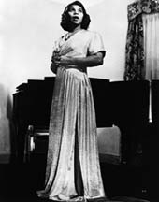
Miami Tower, 100 SE 2nd Street, Miami, FL 33131
(305) 684-4564
Film Series: 19th Floor Auditorium  5 - 6 pm – Reception/Cash bar and snacks  www.miamijazzsociety.com | Jazz Series: 11th Floor Sky Lounge  6 - 10 pm –Cash bar & Food  miamijazzsociety@gmail.com
Weekly movies on most Tuesdays  First film at 6:15 pm, second film at 8:15 pm | Monthly jazz on second Wednesday

