Miami Tower, Sky Lounge, Miami Jazz Society and
Community Cultural Discovery Exchange present
2012
Downtown Jazz Series
Miami Tower Film Series
Community Building and Education Series
October Events
6:15 pm - 8:15 pm | What a Way to Go - Tuesday, 10/2/12  This lavishly produced, big-budget comedy stars Shirley MacLaine as Louisa, a widow who is worth $200 million dollars. However, she's convinced that her fortune is cursed, and she wants to give all her money to the IRS. As she explains her sad tale to her psychiatrist, Dr. Stephanson, it seems that when Louisa was young she had the choice of marrying rich playboy Leonard Crawley or poor but decent Edgar Hopper. She chose Edgar, but soon he became obsessed with providing a fine home and fortune for her; he got rich but worked himself to death in the process. Despondent, Louisa flies to Paris, where she strikes up a romance with expatriate artist Larry Flint. When Larry invents a machine that creates paintings based on sounds, he becomes wealthy and famous -- and dies. Louisa returns to America, where she figures to break her streak by marrying Rod, a business tycoon who already has lots of money. He resolves to take life easier and becomes a farmer, only to die in a strange accident with a bull. Louisa is drowning her sorrows one night at a sleazy night spot when she falls for second rate entertainer Jerry. They marry, and a now-wealthy Jerry develops a relaxed, carefree quality to his act that makes him a huge star, which leads to his being crushed by a mob of his biggest fans. (Comedy) | 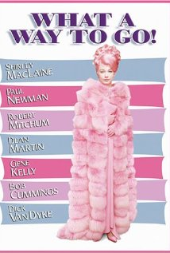
8:30 pm - 10:30 pm | Splendor in the Grass - Tuesday, 10/2/12  It's 1928 in oil rich southeast Kansas. High school seniors Bud Stamper and Deanie Loomis are in love with each other. Bud, the popular football captain, and Deanie, the sensitive soul, are "good" kids who have only gone as far as kissing. Unspoken to each other, they expect to get married to each other one day. They also face pressures from their parents who have their own expectation for their offspring. Bud's overbearing father, Ace Stamper, the local oil baron, does not believe Bud can do wrong and expects him to go to Yale after graduation, which does not fit within Bud's own expectations for himself. And the money and image conscious Mrs. Loomis just wants Deanie to get married as soon as possible to Bud so that Deanie will have a prosperous life in a rich family. When Bud makes a unilateral decision under these pressures, it leads to a path which affects both his and Deanie's future. (Drama/Romance) | 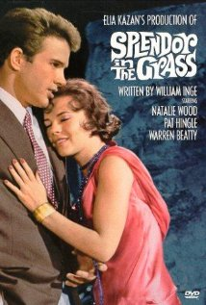
6:15 pm - 8:15 pm | Once Upon a Time in the West - Tuesday, 10/9/12  Story of a young woman, Mrs. McBain, who moves from New Orleans to frontier Utah, on the very edge of the American West. She arrives to find her new husband and family slaughtered, but by who? The prime suspect, coffee-lover Cheyenne, befriends her and offers to go after the real killer, assassin gang leader Frank, in her honor. He is accompanied by Harmonica on his quest to get even. Get-rich-quick subplots and intricate character histories intertwine with such artistic flair that this could in fact be the movie-to-end-all-movies. (Adventure/Western) | 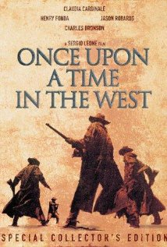
8:30 pm - 10:30 pm | Castle Keep - Tuesday, 10/9/12  During the Battle of the Bulge, an anachronistic count shelters a ragtag squad of Americans in his isolated castle hoping they will defend it against the advancing Germans. Toward the end of World War II, a small company of American GI's occupy an ancient castle. Their commander has an affair with the countess in resident. One guy falls in love with a Volkswagon. A baker among them moves in with another baker's wife. A group of shell shocked holy rollers wander the bombed out streets. A GI art historian tries vainly to protect the castle and its masterpieces. (Drama/Romance/War) | 
7:00 pm - 10:00 pm | Students from the New World School of the Arts (Jazz Band) - Wednesday, 10/10/12
6:15 pm - 8:15 pm | The Golden Blaze - Tuesday, 10/16/12  This incredible feature-length animated movie follows the troubles of two school kids. Fierce rivals, the two regularly butt heads over all manner of issues, ranging from the trivial to the important. The film enters the fantasy realm as an accident occurs and the two boy's fathers suddenly possess some lethal superpowers, allowing them to enter into battle at the behest of their offspring. A bizarre, funny, and exciting movie, GOLDEN BLAZE is an innovative treat for all fans of fast-paced animated action films. (Animation/Family) | 
8:30 pm - 10:30 pm | Bicycle Thieves - Tuesday, 10/16/12  A poor young father in postwar-ravaged Rome who finally finds work putting up Rita Hayworth posters around town, only to have his precious bicycle stolen the first day on the job. In a light moment as the father and his young son chase after the thief, the boy attempts to relieve himself against a wall, and his father lets him know they don't have time for that. In another scene, the father tracks the thief into the kitchen of a brothel. (Crime/Drama) | 
6:15 pm - 8:15 pm | Stranger Than Paradise - Tuesday, 10/23/12  This is about a self-styled New York hipster who is paid a surprise and quite unwelcome visit by his pretty sixteen-year-old Hungarian cousin. From initial hostility and indifference a strange affection grows between the two exiles. Due to complete boredom they decide to visit their aunt in the wastelands of Cleveland and then proceed to sunny Florida where they lose all their money and unwittingly gain a fortune. With a final ironic twist, they are at the end, back where they began. (Comedy/Drama) | 
8:30 pm - 10:30 pm | Broadway Danny Rose - 10/23/12  Danny Rose is a manager of artists, and although he's not very successful, he nevertheless goes out of his way to help his acts. So when Lou Canova, a singer who has a chance of making a come-back, asks Danny to help him with a problem, Danny helps him. This problem is Lou's mistress Tina. Lou wants Tina to be at his concerts, otherwise he can't perform, but he's married, so Danny has to take her along as if she was his girlfriend. Danny however gets more than he has bargained for when two mobsters come looking for the guy who has hurt their brother by stealing the heart of Tina, the girl he loves. (Comedy) | 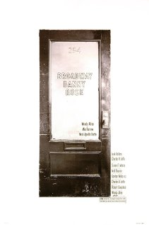
6:15 pm - 8:15 pm | The Blue Angel - Tuesday, 10/30/12  Immanuel Rath, an old bachelor, is a professor at the town's university. When he discovers that some of his pupils often go into a speakeasy, The Blue Angel, to visit a dancer, Lola Lola, he comes there to confront them. But he is attracted to Lola. The next night he comes again--and does not sleep at home. This causes trouble at work and his life takes a downward spiral. (Drama/Musical) | 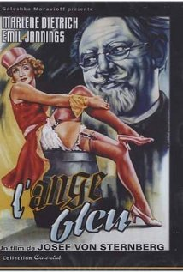
8:30 pm - 10:30 pm | Darling - 10/30/12  Young, attractive and vivacious, model Diana Scott is firmly decided to become rich and famous as well. To succeed, she does not hesitate to take bold steps. After a while, she literally strikes gold: she meets Robert Gold, a well-known TV journalist, who not only introduces her into new social and professional circles, but also abandons his family to live with her. Diana seems to have happily combined success and love. However, in those roaring sixties, others are ready to offer her even more money, fame, and, seemingly, fun than Robert can... (Drama/Romance) | 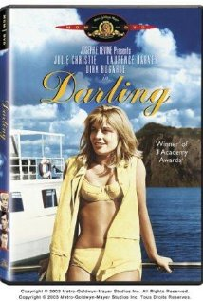
Miami Tower, 100 SE 2nd Street, Miami, FL 33131
(305) 684-4564
Film Series: 19th Floor Auditorium  5 - 6 pm – Reception/Cash bar and snacks  www.miamijazzsociety.com | Jazz Series: 11th Floor Sky Lounge  6 - 10 pm –Cash bar & Food  miamijazzsociety@gmail.com
Weekly movies on most Tuesdays  First film at 6:15 pm, second film at 8:15 pm | Monthly jazz on second Wednesday

