Miami Tower, Sky Lounge, Miami Jazz Society and
Community Cultural Discovery Exchange present
2012
Downtown Jazz Series
Miami Tower Film Series
Community Building and Education Series
November Events
6:15 pm - 8:15 pm | Buck and the Preacher - Tuesday, 11/6/12  A 1972 American Western film starring Sidney Poitier as Buck and Harry Belafonte as the Preacher. Buck is a trail guide leading groups of former slaves trying to homestead in the West, immediately after the American Civil War. The Preacher is a swindling minister of the "High and Low Order of the Holiness Persuasion Church". Together, they protect a wagon train from bounty hunters. (Adventure/Comedy/Drama/Western) | 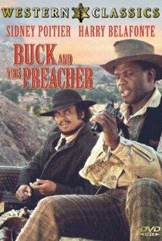
6:15 pm - 8:15 pm | No Way Out - Tuesday, 11/6/12  The Biddle brothers, shot while robbing a gas station, are taken to the prison ward of the County Hospital; Ray Biddle, a rabid racist, wants no treatment from black resident Dr. Luther Brooks. When brother John dies while Luther tries to save him, Ray is certain it's murder and becomes obsessed with vengeance. But there are black racists around too, and the situation slides rapidly toward violence. (Drama/Film-Noir) | 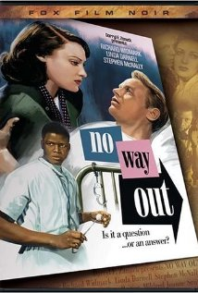
6:15 pm - 8:15 pm | The Best Years of Our Lives - Tuesday, 11/13/12  The story concentrates on the social re-adjustment of three World War II servicemen, each from a different station of society. Al Stephenson returns to an influential banking position, but finds it hard to reconcile his loyalties to ex-servicemen with new commercial realities. Fred Derry is an ordinary working man who finds it difficult to hold down a job or pick up the threads of his marriage. Having had both hands burnt off during the war, Homer Parrish is unsure that his fiancée's feelings are still those of love and not those of pity. Each of the veterans faces a crisis upon his arrival, and each crisis is a microcosm of the experiences of many American warriors who found an alien world awaiting them when they came marching home. (Drama/Romance/War) | 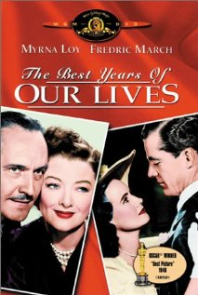
8:30 pm - 10:30 pm | Iron Weed - Tuesday, 11/13/12  Albany, New York, Halloween, 1938. Francis Phelan and Helen Archer are bums, back in their birth city. She was a singer on the radio, he a major league pitcher. Death surrounds them: she's sick, a pal has cancer, he digs graves at the cemetery and visits the grave of his infant son whom he dropped; visions of his past haunt him, including ghosts of two men he killed. That night, out drinking, Helen tries to sing at a bar. Next day, Fran visits his wife and children and meets a grandson. He could stay, but decides it's not for him. Helen gets their things out of storage and finds a hotel. Amidst their mistakes and dereliction, the film explores their code of fairness and loyalty. (Drama) | 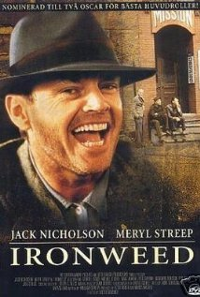
7:00 pm - 10:00 pm | Students from the University of Miami Jazz Band - Wednesday, 11/14/12
6:15 pm - 8:15 pm | Chops - Tuesday, 11/20/12  CHOPS is a documentary about a high school jazz ensemble in Jacksonville, Florida that is accepted to compete in the Essentially Ellington Festival at Lincoln Center in New York City against other top-tier high school jazz ensembles. The film interviews individual musicians about their love of their instruments and the music itself, and shows the ensemble as they face the challenges inherent in learning and practicing music as difficult as that composed by Duke Ellington. After the hours of practice, they arrive in New York City and meet Wynton Marsalis, who helped launch (and is one of the judges in) the Essentially Ellington Festival. (Documentary/Music) | 
8:30 pm - 10:30 pm | Yentl - Tuesday, 11/20/12  Dramatization of "Yentl, the Yeshiva Boy," by Isaac Bashevis Singer (1902-1991); originally published in Yiddish c. 1960, then in English c. 1983. The story: In an Ashkenazic shtetl in Poland, Yentl Mendel is the boyishly klutzy daughter and only child of long widowed Rebbe ("Talmud Teacher") Mendel, who teaches Talmud (a codification of Jewish Law) to local boys - and to Yentl, but secretly because girls were not allowed to learn the law in those days. When her father dies, Yentl is all alone in the world. She takes the momentous decision to leave the village and - disguised as a boy and calling herself by the name of her late brother, Anshel - seeks and gets admitted to a Yeshiva, to study the texts, traditions, subtleties and complexities of Torah, Talmud, etc. She befriends Avigdor who is engaged to Haddas, but her family discovers his brother committed suicide so they call off the wedding (in case Avigdor possesses the same madness)... (Drama/Musical/Romance) | 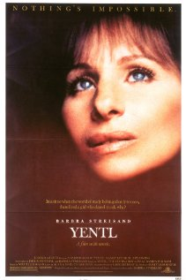
6:15 pm - 8:15 pm | Paris Blues - Tuesday, 11/27/12  Ram Bowen and Eddie Cook are two expatriate jazz musicians living in Paris where, unlike America at the time, Jazz musicians are celebrated and racism is a non-issue. When they meet and fall in love with two young American girls, Lillian and Connie, who are vacationing in France, Ram and Eddie must decide whether they should move back to America with them, or stay in Paris for the freedom it allows them. Ram, who wants to be a serious composer, finds Paris more exciting than America and is reluctant to give up his music for a relationship, and Eddie wants to stay for the city's more tolerant racial atmosphere. (Drama/Music/Romance) | 
8:30 pm - 10:30 pm | Patch of Blue - Tuesday, 11/27/12  Accidentally blinded by her prostitute mother Rose-Ann at the age of five, Selena D'Arcy spends the next 13 years confined in the tiny Los Angeles apartment that they share with "Ole Pa", Selena's grandfather. One afternoon at the local park, Selena meets Gordon Ralfe, a thoughtful young office worker whose kind-hearted treatment of her results in her falling in love with him, unaware that he is black. They continue to meet in the park every afternoon and he teaches her how to get along in the city. But when the cruel, domineering Rose-Ann learns of their relationship, she forbids her to have anything more to do with him because he is black. Selena continues to meet Gordon despite Rose-Ann's fury, who is determined to end the relationship for good. (Drama) | 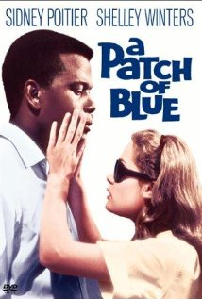
Miami Tower, 100 SE 2nd Street, Miami, FL 33131
(305) 684-4564
Film Series: 19th Floor Auditorium  5 - 6 pm – Reception/Cash bar and snacks  www.miamijazzsociety.com | Jazz Series: 11th Floor Sky Lounge  6 - 10 pm –Cash bar & Food  miamijazzsociety@gmail.com
Weekly movies on most Tuesdays  First film at 6:15 pm, second film at 8:15 pm | Monthly jazz on second Wednesday

