Miami Tower, Sky Lounge, Miami Jazz Society and
Community Cultural Discovery Exchange present
2012
Downtown Jazz Series
Miami Tower Film Series
Community Building and Education Series
December Events
Unforgivable Blackness (Parts 1 & 2)
The story of Jack Johnson, the first African American Heavyweight boxing champion. Ken Burns has done an amazing documentary on the life of Jack Johnson -but even more amazing is the story he tells of the times in which Johnson lived. There is still racism in this country, for sure - one wants to believe that at least in most parts of the country, it is a little more circumspect than racism was during Johnson's life. This documentary provides a truly astounding look at this country at the beginning of the century, and a lot of it is unattractive. Johnson, called "The Ethiopian," could not go after the heavyweight title because the white fighters swore no black man would ever have it. When he finally did get it, Jim Jefferson, the undefeated champion, who had refused to fight Johnson, was dragged out of retirement 10 years and 100 pounds later to try to reclaim the title. He failed, and commented that in his prime, he could never have beat Johnson. In his belief system, Johnson came up against a contemporary, Booker T. Washington, who believed that, rather than worry about segregation, blacks should build a power, education, and money base first. Johnson preferred to live as if segregation did not exist. He lived in white neighborhoods, moved his mother into one, flaunted his money, and consorted with white women. His quest for individualism cost him dearly. He bucked a system that simply would not stand for it. This is a fascinating piece of our history, one that should not be missed. (Documentary/Biography/Short)
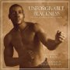
6:15 pm - 8:15 pm | Unforgivable Blackness (Part 1) - Tuesday, 12/4/12
8:30 pm - 10:30 pm | Unforgivable Blackness (Part 2) - Tuesday, 12/4/12
6:15 pm - 8:15 pm | Black Magic - Tuesday, 12/11/12  Examines Civil Rights-era America through the prism of basketball at historically black colleges and universities. At its heart, Black Magic is a civil rights movie and Klores uses brutal footage to show the history of American discrimination and violence against blacks in all aspects of their lives. These civil rights pioneers and sports stars tells us their heart-wrenching stories of violence, prejudice and poverty living in the Jim Crow South. Klores also reminds us that racism and oppression wasn't just limited to the South. Their tales are funny, sad, and inspiring. Some players overcome their humble beginnings and have successful careers despite discrimination, others aren't as lucky. Klores is a wonderful story-teller. He weaves rare footage with personal testimonies and hits the archives to show us documents and photos that give us the insider's view of this world. Narrators Samuel L. Jackson and Wynton Marsalis help frame the story and illuminate the racist historical context. Their passion for the topic shines throughout the film. (Documentary) | 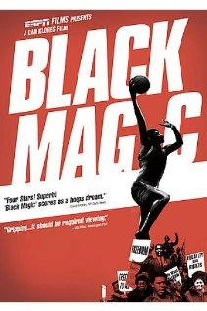
8:30 pm - 10:30 pm | Red Tails - Tuesday, 12/11/12  The 332nd Fighter Group, an all-black World War II unit made up of the best escort pilots and known as the Red Tails, fights racism at home while fighting the Nazis abroad in this action-packed drama based on the true story of the Tuskegee Airmen. The movie also looks a little bit at the men, as individuals. We get to know some of their strengths, weakness, dreams. One doesn't follow directions, and is highly aggressive fighter. One is captured by the Germans. One drinks whiskey. A couple die, due to combat injuries. One is badly injured, and sent home. The pilots finally get a more responsible assignment, do well, and then are given more responsible assignments. The end of the movie is the unit getting recognition for a job well done. (Action/Adventure/Drama/History/War) | 
7:00 pm - 10:00 pm | Students from the University of Miami Jazz Band - Wednesday, 12/12/12
6:15 pm - 8:15 pm | Hugo - Tuesday, 12/18/12  Hugo is an orphan boy living in the walls of a train station in 1930s Paris. He learned to fix clocks and other gadgets from his father and uncle which he puts to use keeping the train station clocks running. The only thing that he has left that connects him to his dead father is an automaton (mechanical man) that doesn't work without a special key which Hugo needs to find to unlock the secret he believes it contains. On his adventures, he meets with a shopkeeper, George Melies, who works in the train station and his adventure-seeking god-daughter. Hugo finds that they have a surprising connection to his father and the automaton, and he discovers it unlocks some memories the old man has buried inside regarding his past. (Adventure/Drama/Family/Mystery | 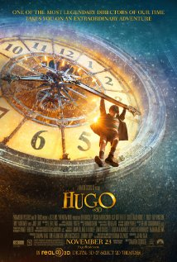
8:30 pm - 10:30 pm | War Horse - Tuesday, 12/18/12  Dartmoor,1914: To his wife's dismay farmer Narracott buys a thoroughbred horse rather than a plough animal, but when his teenaged son Albert trains the horse and calls him Joey, the two becoming inseparable. When his harvest fails, the farmer has to sell Joey to the British cavalry and he is shipped to France where, after a disastrous offensive he is captured by the Germans and changes hands twice more before he is found, caught in the barbed wire in No Man's Land four years later and freed. He is returned behind British lines where Albert, now a private, has been temporarily blinded by gas, but still recognizes his beloved Joey. However, as the Armistice is declared Joey is set to be auctioned off. After all they have been through will Albert and Joey return home together? (Drama/War) | 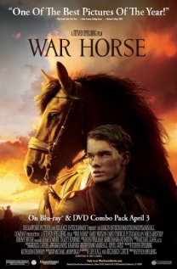
Miami Tower, 100 SE 2nd Street, Miami, FL 33131
(305) 684-4564
Film Series: 19th Floor Auditorium  5 - 6 pm – Reception/Cash bar and snacks  www.miamijazzsociety.com | Jazz Series: 11th Floor Sky Lounge  6 - 10 pm –Cash bar & Food  miamijazzsociety@gmail.com
Weekly movies on most Tuesdays  First film at 6:15 pm, second film at 8:15 pm | Monthly jazz on second Wednesday

