Miami Tower, Sky Lounge, Miami Jazz Society and
Community Cultural Discovery Exchange present
2012
Downtown Jazz Series
Miami Tower Film Series
Community Building and Education Series
August Events
6:15 pm - 8:15 pm | Black Power Mixtape 1967-1975- Tuesday, 8/7/12  Footage shot by a group of Swedish journalists documenting the Black Power Movement in the United States is edited together by a contemporary Swedish filmmaker. (Documentary) | 
8:30 pm - 10:30 pm | Putney Swope - Tuesday, 8/7/12  Dark satire in which the token black man on the executive board of an advertising firm is accidentally put in charge. Renaming the business "Truth and Soul, Inc.", he replaces the tight regime of monied white ad men with his militant brothers. Soon afterwards, however, the power that comes with its position takes its toll on Putney... (Comedy) | 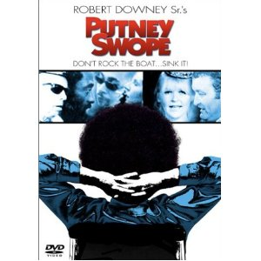
7:00 pm - 10:00 pm | Students from the University of Miami Jazz Band - Wednesday, 8/8/12
6:15 pm - 8:15 pm | Mississippi Masala - Tuesday, 8/14/12  An Indian family is expelled from Uganda when Idi Amin takes power to assist in the building of a railroad.. They move to Mississippi and time passes. The Indian daughter falls in love with a black man, and the respective families have to come to terms with it. Jay gets a rude shock when Anil tells him that Meena is having an affair with a "kaalu" (Black man) named Demetrius Williams, who runs a business cleaning carpets in motel rooms. Watch how tensions rise when salt is rubbed on old wounds, and racism, called "tradition" by some folks in the U.S., raises its ugly head, perhaps to claim more victims - this time Meena and Demetrius - who may not be able to handle the chain of events started by their love for each other. (Romance/Comedy/Drama) | 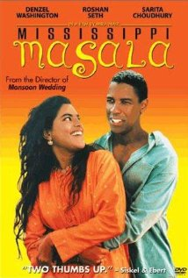
8:30 pm - 10:30 pm | Guess Who’s Coming to Dinner - Tuesday, 8/14/12  Joey Drayton brings her fiancé, Dr. John Prentice, home to sunny San Francisco to meet her affluent parents. Their liberal persuasions are now put to the test, for although the young man is an ideal choice (he's highly and internationally respected in the medical field, and he's impeccably mannered, handsome, well dressed and of a respectable California family), he's black. The film, which covers one busy day in the Drayton home, is essentially a drawing-room comedy, a series of cross-conversations between the young doctor and the girl's parents, and finally between all sets of parents and offspring. A simple dinner is extended to include the doctor's parents, who fly up from Los Angeles for the evening, and the crusty but benevolent old Irish priest, a friend of the family. Thus, the title of the film . . . (Drama/Romance) | 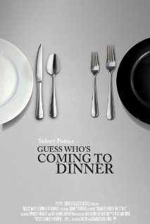
6:15 pm - 8:15 pm | Charlie Chaplin: The Forgotten Years - Tuesday, 8/21/12  This documentary about Charlie Chaplin focuses on his late years when he lived with his family in a village on Lake Geneva in Switzerland. His personal life and his love for the circus are depicted as well as the late works of his professional career, including his extensive work as a composer. In addition, the film reveals the Swiss intelligence agency's file on Chaplin. Features numerous archive clips and new interviews with family members and various entertainment stars, including Petula Clark, who sings her Chaplin-written hit "This Is My Song" in his villa. (Documentary/Biography) | 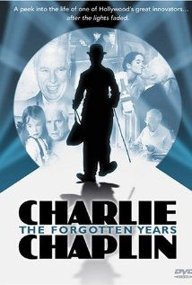
8:30 pm - 10:30 pm | Modern Times - Tuesday, 8/21/12  Chaplins last 'silent' film, filled with sound effects, was made when everyone else was making talkies. Charlie turns against modern society, the machine age, (The use of sound in films ?) and progress. Firstly we see him frantically trying to keep up with a production line, tightening bolts. He is selected for an experiment with an automatic feeding machine, but various mishaps leads his boss to believe he has gone mad, and Charlie is sent to a mental hospital... When he gets out, he is mistaken for a communist while waving a red flag, sent to jail, foils a jailbreak, and is let out again. We follow Charlie through many more escapades before the film is out. (Comedy/Drama/Romance) | 
6:15 pm - 8:15 pm | The Red Balloon - Tuesday, 8/28/12  In Paris, a French schoolboy makes friends with a red balloon and vice-versa, with the balloon following him around like a pet. It stays out of the reach of other would-be captors, but a gang of boys destroys it eventually. Then other balloons of various sizes and colors descend on the boy from all parts of Paris, and together they lift him into the sky and take him away over the horizon. (Family/Fantasy/Short) | 
8:30 pm - 10:30 pm | Muppets from Space - 8/28/12  After Gonzo receives messages from his breakfast cereal, he determines that he is an alien and tries to contact his alien brethren, but is captured by an overzealous secret government agency determined to prove the existence of extraterrestrial life. It's up to Kermit and the gang to rescue Gonzo and help reunite him with his long-lost family. (Family/Comedy/Sci-Fi/Adventure) | 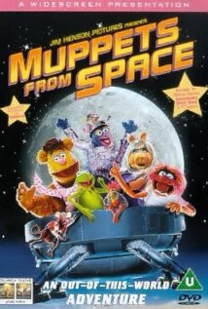
Miami Tower, 100 SE 2nd Street, Miami, FL 33131
(305) 684-4564
Film Series: 19th Floor Auditorium  5 - 6 pm – Reception/Cash bar and snacks  www.miamijazzsociety.com | Jazz Series: 11th Floor Sky Lounge  6 - 10 pm –Cash bar & Food  miamijazzsociety@gmail.com
Weekly movies on most Tuesdays  First film at 6:15 pm, second film at 8:15 pm | Monthly jazz on second Wednesday

