Miami Tower, Sky Lounge, Miami Jazz Society and
Community Cultural Discovery Exchange present
2012
Downtown Jazz Series
Miami Tower Film Series
Community Building and Education Series
May Events
6:15 pm - 8:15 pm | Mutluluk (Bliss) - Tuesday, 5/1/12  When a young woman named Meryem is raped, her village custom requires that she be killed in order for the dishonour to be expunged from her family. A young man named Cemal, the son of the village leader, is given the task but at the last moment he has doubts. The pair go on the run, followed close behind by local thugs intent on killing the girl. Luckily enough, Cemal and Meryem meet up with a charismatic man named Irfan, an ex-university professor who is embarking on a sailing trip, and needs a crew. Seems Irfan is running away too--in his case from a dead marriage and an empty life. Together this unlikely trio set forth on a voyage that will change all of their lives. (Drama) | 
8:30 pm - 10:30 pm | Letter From An Unknown Woman - Tuesday, 5/1/12  In Vienna, about 1900, a dashing man arrives at his flat, instructing his manservant that he will leave before morning: the man is Stefan Brand, formerly a concert pianist, planning to leave Vienna to avoid a duel. His servant gives him a letter from an unknown woman, which he reads. In flashbacks we see the lifelong passion of Lisa Berndle for him: first as a girl who was his neighbor; next as a young woman who, in secret, has his child; then as a mature woman who meets him again and abandons husband and son to be with him. Each time he does not remember who she is or that they have ever met. By morning, he has finished the letter, and her husband awaits satisfaction. (Drama/Romance) | 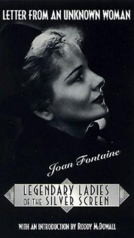
6:15 pm - 8:15 pm | American Violet - Tuesday, 5/8/12  Set in the midst of the 2000 presidential election, American Violet tells the story of Dee Roberts, a 24 year-old African-American single mother of four, living in a small Texas town (based after Hearne, Texas where the real incident took place). One day, while Dee is working a shift at the local diner, the powerful local district attorney leads a drug bust, sweeping Dee’s housing project. Police drag Dee from work in handcuffs, dumping her in the women’s county prison. Indicted based on the uncorroborated word of a single and dubious police informant facing his own drug charges, Dee soon discovers she has been charged as a drug dealer. Even though Dee has no prior drug record and no drugs were found on her in the raid or any subsequent searches, she is offered a hellish choice: plead guilty and go home as a convicted felon or remain in prison and fight the charges thus, jeopardizing her custody and risking a long prison sentence. Despite the urgings of her mother, and with her freedom and the custody of her children at stake, she chooses to fight the district attorney. Dee works with an ACLU attorney and a former local narcotics officer to take on the Texas justice system. (Drama) | 
8:30 pm - 10:30 pm | Gregory Peck: His Own Man - Tuesday, 5/8/12  One of Hollywood's most enduring and popular stars draws on his memories to tell the amusing and touching story of how it was when the studios ruled supreme, and how a shy and inarticulate boy from a broken family could rise to super stardom to become one of the most handsome, attractive and respected of movie leading men. His early career proved his talent; his later years showed that with the talent came a wise and humane individual. Unfashionably modest in these days of hard-hitting self-aggrandizement, Peck takes us with him on this long and fascinating journey from early theater roles, through his first film parts up to today. (Documentary) | 
7:00 pm - 10:00 pm | Students from the University of Miami Jazz Band - Wednesday, 5/9/12
6:15 pm - 8:15 pm | Carmen Jones - Tuesday, 5/15/12  At an all-black army camp, civilian parachute maker and "hot bundle" Carmen Jones is desired by many of the men. Naturally, she wants Joe, who's engaged to sweet Cindy Lou and about to go into pilot training for the Korean War. Going after him, she succeeds only in getting him into the stockade. While she awaits his release, trouble approaches for both of them. Songs from the Bizet opera with modernized lyrics. (Drama/Musical/Romance) | 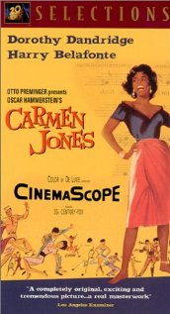
8:30 pm - 10:30 pm | Dorothy Dandridge in concert series/bonus biography - Tuesday, 5/15/12  Born November 9, 1922, in Cleveland, Ohio, Dorothy Dandridge sang at Harlem's Cotton Club and Apollo Theatre and became the first African American woman to be nominated for an Academy Award for Best Actress. Many years passed before the entertainment industry acknowledged Dandridge's legacy. Her next role, as the eponymous lead in Carmen Jones (1954),a film adaptation of Bizet's opera Carmen that also costarred Belafonte, catapulted her to the heights of stardom. With her sultry looks and flirtatious style, Dandridge became the first African-American to earn an Academy Award nomination for Best Actress. Though many believed she deserved to win, Dandridge eventually lost the award to Grace Kelly (The Country Girl). Still, after the phenomenal success of Carmen Jones, Dandridge seemed well on her way to becoming the first non-white actress to achieve the kind of superstardom that had accrued to contemporaries like Marilyn Monroe and Ava Gardner. In 1955, she was featured on the cover of Life magazine, and was treated like visiting royalty at that year’s Cannes Film Festival. | 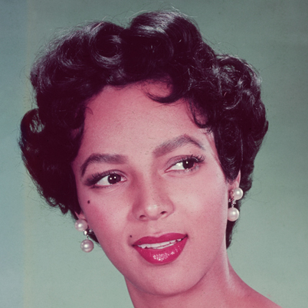
6:15 pm - 8:15 pm | Moolaadé - Tuesday, 5/22/12  In an African village this is the day when six 4-9-year-old girls are to be circumcised. All children know that the operation is horrible torture and sometimes lethal, and all adults know that some circumcised women can only give birth by Caesarean section. Two of the girls have drowned themselves in the well to escape the operation. The four other girls seek "magical protection" by a woman who seven years before refused to have her daughter circumcised. Moolaadé is indicated by a coloured rope. But no one would dare step over and fetch the children. Moolaadé can only be revoked by Colle herself. Her husband's relatives persuade him to whip her in public into revoking. Opposite groups of women shout to her to revoke or to be steadfast, but no woman interferes. When Colle is at the wedge of fainting, the merchant takes action and stops the maltreatment. Therefore he is hunted out of the village and, when out of sight, murdered. (Drama) | 
8:30 pm - 10:30 pm | Freedom Riders - Tuesday, 5/22/12  a 2010 American historical documentary film, produced by Firelight Media for PBS American Experience based in part on the book Freedom Riders: 1961 and the Struggle for Racial Justice by historian Raymond Arsenault. Directed by Stanley Nelson, it marked the 50th anniversary of the first Freedom Ride in May 1961 and was first aired on May 16, 2011. The film chronicles the story behind hundreds of civil rights activists called the Freedom Riders who challenged the racial segregation of the American interstate transport and by traveling together in small interracial groups and sitting where they chose on the buses and trains to demand equal access to terminal restaurants and waiting rooms, and to bring racial segregation national attention. The film is currently used within Firelight Media’s national outreach campaign, to serve as an educational and advocacy tool by NGOs and non-profit partners in order to support young people who are mobilizing around contemporary social issues such as, immigrant rights, youth violence, and environmental issues. The film was also featured on the Oprah Winfrey Show program titled, Freedom Riders: 50th Anniversary. (Documentary) | 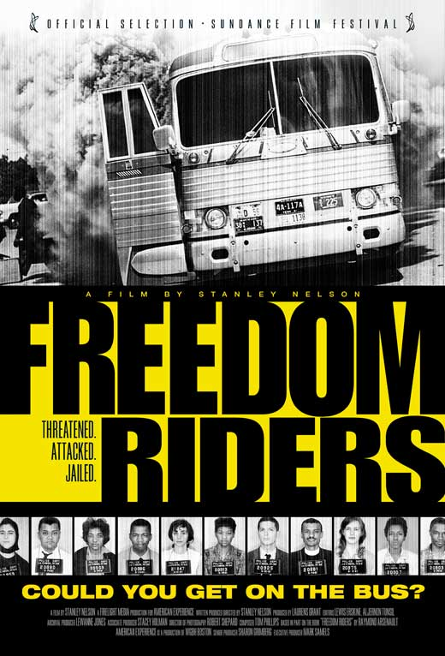
6:15 pm - 8:15 pm | All About Eve - Tuesday, 5/29/12  Aspiring actress Eve Harrington maneuvers her way into the lives of Broadway star Margo Channing, playwright Lloyd Richards and director Bill Sampson. This classic story of ambition and betrayal has become part of American folklore. Bette Davis claims to have based her character on the persona of film actress Talullah Bankhead. Davis' line "Fasten your seatbelts, it's going to be a bumpy night" is legendary, but, in fact, all of the film's dialog sparkles with equal brilliance. (Drama) | 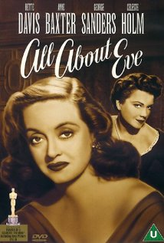
8:30 pm - 10:30 pm | The African Queen - Tuesday, 5/29/12  September 1914, news reaches the colony German Eastern Africa that its motherland is at war, so Reverend Samuel Sayer became a hostile foreigner; German imperial troops burn down his mission, driving him mad- shortly after his well-educated, snooty sister Rose Sayer buries him and leaves by the only available transport, the crummy river steamboat 'African Queen' of grumpy boorish compatriot Charlie Allnut. As if a long difficult journey without any comfort weren't bad enough for such odd companions, she is determined to find a way to do their bit for the British war effort (and revenge her brother) and aims high as God is obviously on their side: construct their own equipment, a torpedo and the converted steamboat, to take out a huge German warship, the Louisa, which is hard to find on the giant lake and first of all to reach, in fact as daunting an expedition as nobody attempted since the late adventurous explorer John Speakes. (Adventure/Drama/Romance/War) | 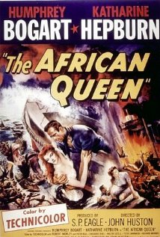

Miami Tower, 100 SE 2nd Street, Miami, FL 33131
(305) 684-4564
Film Series: 19th Floor Auditorium  5 - 6 pm – Reception/Cash bar and snacks  www.miamijazzsociety.com | Jazz Series: 11th Floor Sky Lounge  6 - 10 pm –Cash bar & Food  miamijazzsociety@gmail.com

