Miami Tower, Sky Lounge, Miami Jazz Society and
Community Cultural Discovery Exchange present
2012
Downtown Jazz Series
Miami Tower Film Series
Community Building and Education Series
April Events
6:15 pm - 8:15 pm | Adam’s Rib - Tuesday, 4/3/12  Assistant District Attorney Adam Bonner is assigned to prosecute a woman who tries to shoot her unfaithful husband. The DA and Bonner both expect a quick win. But neither planned on Bonner's wife and fellow attorney, Amanda Bonner, of defending the woman on the basis of "equal rights under the law," which Ms. Bonner insists would vindicate a man who would try to kill the lover of his unfaithful wife. Ms. Bonner shows throughout the court case that the law and society treat women different from men, and that any person would resort to violence if pushed sufficiently far. Mr. Bonner insists that regardless, no individual can take the law into his or her own hands, or chaos would ensue. | 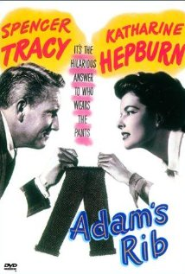
8:30 pm - 10:30 pm | To Have and Have Not - Tuesday, 4/3/12  Harry Morgan and his alcoholic sidekick, Eddie, are based on the island of Martinique and crew a boat available for hire. However, since the second world war is happening around them business is not what it could be and after a customer who owes them a large sum fails to pay they are forced against their better judgement to violate their preferred neutrality and to take a job for the resistance transporting a fugitive on the run from the Nazis to Martinique. Through all this runs the stormy relationship between Morgan and Marie "Slim" Browning, a resistance sympathizer and the sassy singer in the club where Morgan spends most of his days. | 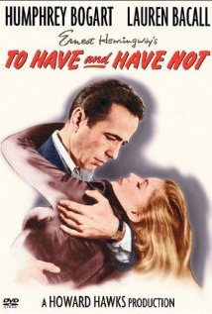
6:15 pm - 9:00 pm | Lady Be Good: Instrumental Women in Jazz - Tuesday, 4/10/12  LADY BE GOOD focuses on women who played jazz during decades when to be a woman in jazz was to be truly an exception. The homebound status of women was enhanced by women learning to play the piano. Emerging from these homes were excellent women musicians who joined minstrel bands and Ladies Orchestras in the late 1800’s. From this beginning and into the twentieth century, these women moved to the all-women jazz bands, mostly male jazz bands, the women units of the thirties, to the big bands and swing units of the forties and to the combos of the fifties. These chapters of the ongoing story of women in jazz show that many were discouraged by prejudice and an unreceptive culture. Their presence, often against formidable odds, constituted a rebuttal to the argument that women cannot and should not play most instruments. These women are a part of history as pioneers and role models. | 
7:00 pm - 10:00 pm | Yvonne Brown (Jazz Band) - Wednesday, 4/11/12  With authentic precision and effortless intensity, Brown is a master performer of the American Jazz songbook. Like sugar and salt, her voice is sweet and powerful; full of emotional nuances reminiscent of some of the foremost greats of Jazz, including Ella Filtzgerald, Sarah Vaughan, Shirley Horn, Nina Simon, Etta Jones, with a tinge of Billie Holiday. | 
6:15 pm - 9:00 pm | Billie Holiday Documentaries - Tuesday, 4/17/12
6:15 pm - 8:15 pm | My Fair Lady - Tuesday, 4/24/12  Gloriously witty adaptation of the Broadway musical about Professor Henry Higgins, who takes a bet from Colonel Pickering that he can transform unrefined, dirty Cockney flower girl Eliza Doolittle into a lady, and fool everyone into thinking she really is one, too! He does, and thus young aristocrat Freddy Eynsford-Hill falls madly in love with her. But when Higgins takes all the credit and forgets to acknowledge her efforts, Eliza angrily leaves him for Freddy, and suddenly Higgins realizes he's grown accustomed to her face and can't really live without it. | 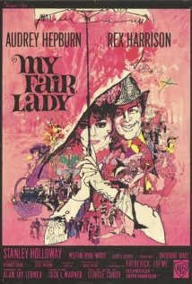
8:30 pm - 10:30 pm | Shall We Dance (Japan) - Tuesday, 4/24/12  Shohei Sugiyama has attained all that he has wanted in life. But he is still depressed and unhappy. One day, he gathers up the courage to sign up for dancing lessons. He hopes they will rid his depression and help him get his life back together. The accountant Shohei Sugiyama (Kôji Yakusho) is feeling bored with his routine life, limited to hard work and stay at home with his wife Masako Sugiyama (Hideko Hara) and his teenager's daughter. One night, while traveling home by train, he sees the beautiful face of Mai Kishikawa (Tamiyo Kusakari) in the balcony of a dance school, and a couple of days later, he decides to visit the school and secretly take ballroom dance lessons every Wednesdays night. However, he becomes ashamed to tell his family his secret. Meanwhile, Masako feels the changes in the behavior of her happier husband, and hires a private eye to investigate whether Shohei is having an affair.
Miami Tower, 100 SE 2nd Street, Miami, FL 33131
(305) 684-4564
Film Series: 19th Floor Auditorium  5 - 6 pm – Reception/Cash bar and snacks  www.miamijazzsociety.com | Jazz Series: 11th Floor Sky Lounge  6 - 10 pm –Cash bar & Food  miamijazzsociety@gmail.com

